AB WEBDESIGN
GRAPHICS & ANIMATION
You can find the material on the server:
X:\2023\And Beyond\And Beyond Full Branding\08 Website\01 Webdesign\03 Services\04 Graphics & Animation
Color code: f8c113
Color code: 5c4199

Header
- Found in the “00 Headers” folder + add the following title “Graphics & Animation” in White
- Remove the social media titles
- Remove the sound feature
- Remove title “Start Engine”
- Replace “We create…” with following text:
Our dynamic heroes breathe life into your concepts, crafting them into their very best. With a blend of creativity and technical expertise, we ensure your ideas are brought to life in the most captivating and effective manner
- For Projects section you can find the images on the server:
X:\2023\And Beyond\And Beyond Full Branding\08 Website\01 Webdesign\03 Services\02 Production\01 Projects

Visual Reference of how the projects should look:
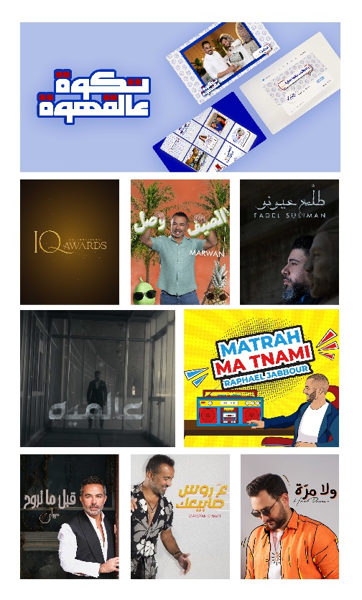
Links: (left to right)
1- https://www.instagram.com/taqwa3alqahwa/
2- https://youtu.be/3coxziSakGE
3- https://www.youtube.com/watch?v=HNLNdiglKFY
4- https://www.youtube.com/watch?v=ZN_DCzCWNFM
5- Saif Nabeel - Aalamiya [Official Lyric Video] (2021) / سيف نبيل - عالميه - YouTube
6- https://www.youtube.com/watch?v=Haj_BY3e3g0
7- https://www.youtube.com/watch?v=oVAXcczT-f4
8- https://www.youtube.com/watch?v=r1YBrHwogFg
9- https://www.youtube.com/watch?v=QWInfsmXnMA

